Chapter 9 Kinetics name: class:
考点 A: 反应速率 Reaction Rates

1. 2N₂O₅ (g) -> 4NO₂ (g) + O₂ (g).
At high temperatures, N₂O₅ (g) decomposes according to the equation above. A sample of N₂O₅ (g) is monitored as it decomposes, and the concentration of N₂O₅ (g) as a function of time is recorded:
Time=0 s, [N₂O₅]=0.850 M;
Time=60.0 s, [N₂O₅]=0.654 M;
Time=120.0 s, [N₂O₅]=0.532 M;
Time=180.0 s, [N₂O₅]=0.448 M.
What is the average rate of the reaction between 120.0 and 180.0 seconds? （ ）
A. Option A⁻⁴ M s⁻¹
B. Option B⁻³ M s⁻¹
C. Option C⁻³ M s⁻¹
D. Option D⁻³ M s⁻¹

2. Ammonia decomposes into nitrogen gas and hydrogen gas, at high temperatures. A sample of ammonia is monitored as it decomposes, and the concentration of hydrogen is recorded over time:
Time=0 s, [H₂]=0.646 M;
Time=60.0 s, [H₂]=0.491 M;
Time=120.0 s, [H₂]=0.388 M;
Time=180.0 s, [H₂]=0.318 M.
What is the average rate of the reaction between 60.0 and 120.0 seconds? （ ）
A. Option A⁻⁴ M s⁻¹
B. Option B⁻⁴ M s⁻¹
C. Option C⁻³ M s⁻¹
D. Option D⁻³ M s⁻¹

3. CaCO₃ (s) + H₂SO₄ (aq) -> CaSO₄ (aq) + H₂O (l) + CO₂ (g).
The reaction between CaCO₃ (s) and H₂SO₄ (aq) is represented by the equation above.
In a kinetics experiment, a 0.25 g sample of powdered CaCO₃ (s) is added to a flask containing 50 mL of 1.5 M H₂SO₄ (aq) at 25 oC.
The rate of the reaction is determined by measuring the volume of CO₂ (g) produced over time.
Which of the following experimental changes is most likely to increase the rate of CO₂ (g) production? （ ）
A. Using a 0.25 g sample of CaCO₃ (s) chips instead of powdered CaCO₃ (s).
B. Using 1.0 M H₂SO₄ (aq) instead of 1.5 M.
C. Using 100 mL of 1.5 M H₂SO₄ (aq) instead of 50 mL.
D. Warming the H₂SO₄ (aq) to 35 oC before its addition to the CaCO₃ (s).

考点 B: 碰撞理论 Collision Theory

1. Increasing temperature increases reaction rate because: （ ）
A more collisions occur.
B particles have lower activation energy.
C a larger fraction of molecules have kinetic energy ≥ Ea.
D the equilibrium constant increases.

2. According to the collision model, which of the following factors does NOT directly affect the rate of a chemical reaction? （ ）
A. Option A
B. Enthalpy change of the reaction
C. Frequency of collisions
D. Orientation of colliding molecules

3. How does the average kinetic energy of a gas vary with temperature? (Refer to the graphs provided in the original exam paper.) （ ）
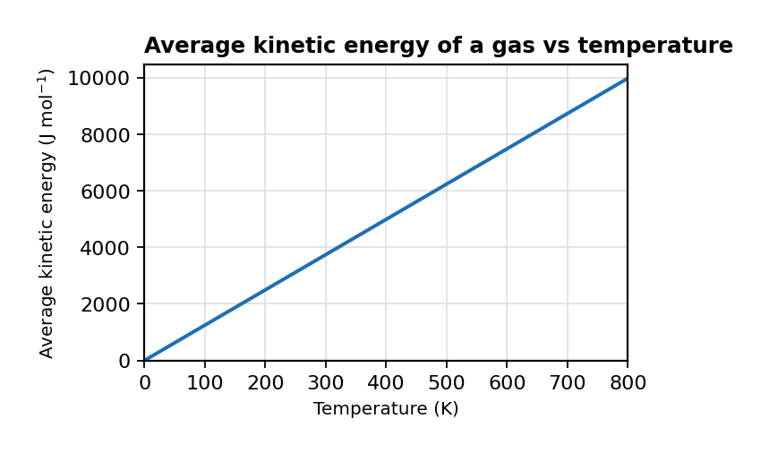
图 C₉-1：气体平均动能随温度变化（对应考点 B MCQ3）
A. Option A
B. Option B
C. Option C
D. Option D

4. How does an increase in temperature affect the Maxwell-Boltzmann distribution of molecular energies? （ ）
A. It narrows the distribution and shifts the peak to higher energies.
B. It widens the distribution and shifts the peak to lower energies.
C. It narrows the distribution and shifts the peak to lower energies.
D. It widens the distribution and shifts the peak to higher energies.

5. The Maxwell-Boltzmann distribution of molecular energies in sample 1 of a gas is shown. A change was made to the reaction conditions, as shown by the dotted curve, labelled sample 2.
What factor was changed in the reaction conditions to produce the dotted curve, labelled sample 2? （ ）
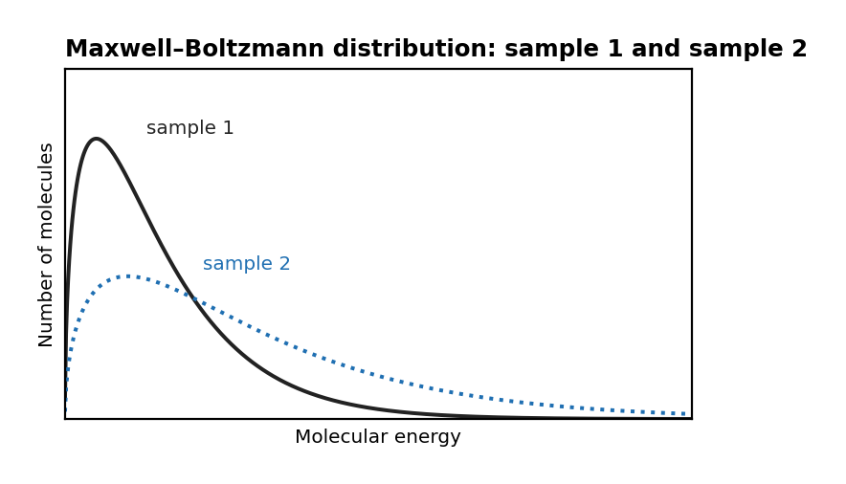
图 C₉-2：Maxwell–Boltzmann 分布曲线（对应考点 B MCQ5）
A. Option A
B. Option B
C. Temperature increased
D. Option D

6. The diagrams below show Boltzmann energy distribution curves and activation energy lines for a chemical reaction.
In Diagram 1, line P or Q represents the activation energy with a catalyst, while the other represents the activation energy without a catalyst.
In Diagram 2, curve X or Y corresponds to a higher temperature than the other curve.
Which combination correctly identifies the line and curve? （ ）
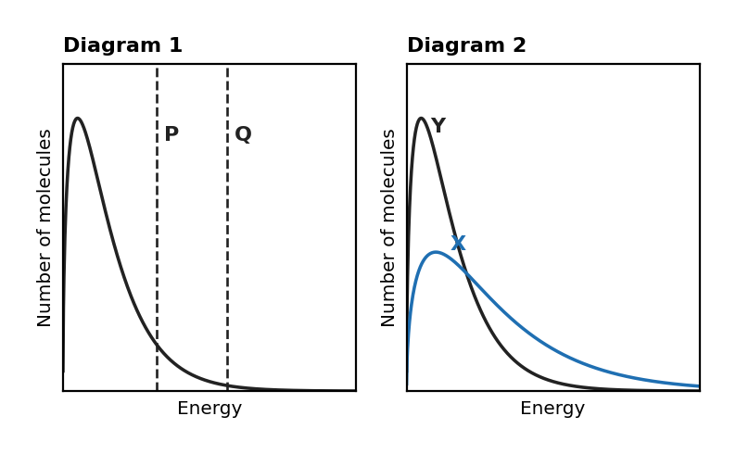
图 C₉-3：Boltzmann 能量分布与活化能线（对应考点 B MCQ6）
A. Activation energy with catalyst: P; Higher temperature: X
B. Activation energy with catalyst: P; Higher temperature: Y
C. Activation energy with catalyst: Q; Higher temperature: X
D. Activation energy with catalyst: Q; Higher temperature: Y

7. The Arrhenius equation is given as:
Which of the following best describes the role of the pre-exponential factor (A) in the Arrhenius equation? （ ）
A. It represents the fraction of molecules with sufficient energy to react, considering the effect of temperature.
B. It accounts for the total number of molecular collisions and the fraction of correctly oriented collisions that result in a reaction.
C. It is directly proportional to activation energy and determines the minimum energy required for reaction.
D. It is the probability that a molecule will have enough energy to overcome the activation barrier.

考点 C: 速率方程 Rate Law
1. 掌握通过初始速率数据确定速率方程
Rate law: rate = k[A]^m[B]^n; Determine m, n by comparing experiments where only one [ ] changes
Overall order = m + n; Units of k depend on overall order

1. For 2 NO + 2 H₂ → N₂ + 2 H₂O, data: [NO]=0.100,[H₂]=0.100,rate=1.23×10-3; [NO]=0.100,[H₂]=0.200,rate=2.46×10-3; [NO]=0.200,[H₂]=0.100,rate=4.92×10-3.
(a) Determine order with respect to NO and H₂. [2 marks]
(b) Write the rate law and calculate k (with units). [2 marks]
(c) Calculate rate when [NO]=0.150 M and [H₂]=0.150 M. [1 mark]

2. For A + 2B → C: [A]=0.100,[B]=0.100,rate=5.0×10-4; [A]=0.200,[B]=0.100,rate=2.0×10-3; [A]=0.100,[B]=0.200,rate=1.0×10-3.
(a) Determine order and write the rate law with k and units. [4 marks]

2. 掌握一级反应动力学
First-order: ln[A] = ln[A]₀ − kt; half-life t½ = ln2/k (constant for first-order)
Integrated rate law: [A] = [A]₀ e^(−kt)

1. N₂O₅ decomposition: 2 N₂O₅ → 4 NO₂ + O₂, first-order, k=4.80×10⁻⁴ s⁻¹ at 300K. [N₂O₅]₀=0.160 M.
(a) Calculate [N₂O₅] after 1000 s. [2 marks]
(b) Calculate the half-life. [1 mark]
(c) How long for 90.0% to decompose? [2 marks]

1. For the reaction C₂H₅Br (aq) + OH- (aq) -> C₂H₅OH (aq) + Br- (aq), the following data were collected at constant temperature:
Exp 1: [C₂H₅Br]=3.0x10^-3 M, [OH-]=2.0x10^-2 M, Rate=4.0x10^-4 M s^-1;
Exp 2: [C₂H₅Br]=6.0x10^-3 M, [OH-]=2.0x10^-2 M, Rate=8.0x10^-4 M s^-1;
Exp 3: [C₂H₅Br]=6.0x10^-3 M, [OH-]=4.0x10^-2 M, Rate=1.6x10^-3 M s^-1.
What is the correct rate law for this reaction? （ ）
A. Rate = k [C₂H₅Br] [OH-]
B. Rate = k [C₂H₅Br] [OH-]2
C. Rate = k [C₂H₅Br]2 [OH-]
D. Rate = k [C₂H₅Br]2 [OH-]2

2. The following reaction was studied at a constant temperature: 5 Br- (aq) + BrO₃- (aq) + 6 H+ (aq) -> 3 Br₂ (aq) + 3 H₂O (l).
Data was collected for the rate of the reaction.
Which rate expression is consistent with the data? （ ）
A. Rate = k [Br-] [BrO₃-] [H+]
B. Rate = k [Br-]2 [H+]2
C. Rate = k [Br-] [BrO₃-] [H+]2
D. Rate = k [Br-]2 [BrO₃-] [H+]

3. The rate expression for the reaction between iodine and propanone is determined to be:
Rate = k [H+] [C₃H₆O].
Which graph is consistent with this information? (Refer to the graphs provided in the original exam paper.) （ ）
A. [Concentration] decreases linearly with time (zero-order kinetics)
B. Option B
C. Option C
D. Option D

4. An investigation into the rate of reaction between compounds A and B was performed. A + B -> C + D.
The results from three different experiments carried out at a constant temperature were collected:
Exp 1: [A]=0.30 M, [B]=0.50 M, Rate=6.0x10^-4 M s^-1;
Exp 2: [A]=0.30 M, [B]=0.25 M, Rate=1.5x10^-4 M s^-1;
Exp 3: [A]=0.60 M, [B]=0.25 M, Rate=3.0x10^-4 M s^-1.
The rate equation for this reaction is rate = k [A] [B]^2.
What is the value of the rate constant, k? （ ）
A. Option A⁻³
B. Option B⁻²
C. Option C⁻³
D. Option D⁻²

5. The reaction between ethyl bromide and hydroxide ions was studied at a constant temperature: C₂H₅Br (aq) + OH- (aq) -> C₂H₅OH (aq) + Br- (aq).
Experimental data:
Exp 1: [C₂H₅Br]=2.0x10^-3, [OH-]=1.0x10^-2, Rate=4.0x10^-4;
Exp 2: [C₂H₅Br]=4.0x10^-3, [OH-]=1.0x10^-2, Rate=8.0x10^-4;
Exp 3: [C₂H₅Br]=8.0x10^-3, [OH-]=2.0x10^-2, Rate=3.2x10^-3.
What is the correct equation to calculate the value of the rate constant, k? (Refer to the equations provided in the original exam paper.) （ ）
A. Option A
B. Option B
C. Option C
D. Option D

6. A rate law is found to be Rate = k [A]2 [B] Which of the following changes will not alter the initial rate of reaction? （ ）
A. Doubling the concentration of A and B
B. Doubling the concentration of A and halving the concentration of B
C. Halving the concentration of A and doubling the concentration of B
D. Halving the concentration of A and quadrupling the concentration of B

7. For the general reaction V + W + X → Y + Z, the rate equation is: rate = k [V] [W] [X] What will happen to the rate of reaction when the concentration of all three reactants is doubled? （ ）
A. Increase by a factor of 2
B. Increase by a factor of 4
C. Increase by a factor of 6
D. Increase by a factor of 8

8. Which of the following statements about the integrated rate law for a first-order reaction is true? （ ）
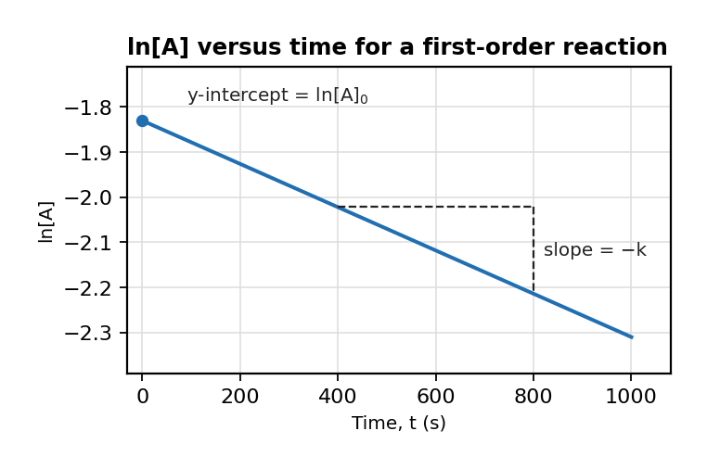
图 C₉-4：一级反应 ln[A] 对时间作图（对应考点 C MCQ8）
A. The x-intercept of the ln[A] vs. t plot represents the half-life of the reaction.
B. The y-intercept of the ln[A] vs. t plot represents the initial concentration of A.
C. The slope of the ln[A] vs. t plot is equal to -k.
D. The area under the ln[A] vs. t plot represents the total amount of product formed.

9. A first-order reaction has a half-life of 62 s. What fraction of reactant remains after 124 s? （ ）
A. Option A
B. Option B
C. Option C
D. Option D

10. In a first-order reaction, the half-life of the reactant is 30 minutes.
How long will it take for the concentration of the reactant to decrease to 12.5% of its initial value? （ ）
A. Option A
B. Option B
C. Option C
D. Option D

考点 D: 反应机理 Reaction Mechanisms
3. 掌握反应机理和速率决定步骤
Rate-determining step (速率决定步骤): the slowest elementary step — its rate law matches the overall rate law
Intermediate: produced and consumed within the mechanism; not in overall equation
Catalyst: lowers Ea by providing alternative pathway; does NOT change ΔH or K

1. Which of the following statements about reaction mechanisms is true? （ ）
A. Catalysts are not involved in elementary reactions.
B. Intermediates appear in the overall balanced equation.
C. The rate-determining step is always the last step in a mechanism.
D. The sum of the elementary steps must equal the overall balanced equation.

2. For mechanism: Step1: 2HI → H₂ + 2I (slow); Step2: 2I → I₂ (fast). The rate law is: （ ）
A rate = k[HI]²
B rate = k[HI]
C rate = k[I]²
D rate = k[H₂][I₂]

3. For the elementary reaction A + B → C, what is the correct rate law? （ ）
A. Option A
B. Option B
C. Option C
D. Rate = k[C] / ([A][B])

4. What is the significance of an intermediate species in a proposed reaction mechanism? （ ）
A. It appears in the overall balanced equation but not in the elementary steps.
B. It is produced in one elementary step and consumed in a subsequent step.
C. It catalyzes the reaction without being consumed.
D. It is always the limiting reagent in the overall reaction.

5. Which of the following best describes the rate-limiting step in a multi-step reaction mechanism? （ ）
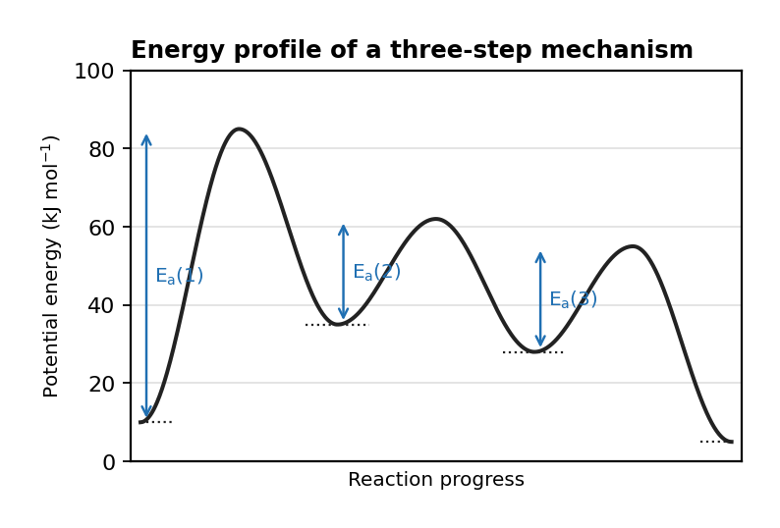
图 C₉-5：多步反应机理能量图（对应考点 D MCQ5）
A. The step with the lowest activation energy.
B. The step with the highest rate constant.
C. The step with the highest activation energy.
D. The step that produces the most stable intermediate.

6. Consider the following mechanism for a reaction:
Step 1: N₂O₅ (g) → NO₂ (g) + NO₂+ (g) Step 2: N₂O₅ (g) + NO₂+ (g) → NO₂ (g) + NO₃− (g) Step 3: 2NO₃− (g) → O₂ (g) + 2NO₂ (g) Which of the following correctly identifies the reaction intermediates? （ ）
A. Option A
B. Option B
C. N₂O₅ (g) and NO₂+ (g)
D. NO₂+ (g) and NO₃− (g)

7. The mechanism for the following reaction between iodine and propanone is shown. CH₃COCH₃ (aq) + I₂ (aq) -> CH₃COCH₂I (aq) + HI (aq).
Step 1: CH₃COCH₃ + H+ -> CH₃COH+CH₃.
Step 2: CH₃COH+CH₃ -> CH₃COHCH₂ + H+.
Step 3: CH₃COHCH₂ + I₂ -> CH₃COHCH₂I + I-.
Step 4: CH₃COHCH₂I -> CH₃COCH₂I + H+.
Which of the following classifications of CH₃COCH₃, H+ and CH₃COHCH₂ are correct? （ ）
A. CH₃COCH₃: Intermediate; H+: Intermediate; CH₃COHCH₂: Catalyst
B. CH₃COCH₃: Reactant; H+: Intermediate; CH₃COHCH₂: Product
C. CH₃COCH₃: Reactant; H+: Catalyst; CH₃COHCH₂: Intermediate
D. CH₃COCH₃: Reactant; H+: Product; CH₃COHCH₂: Intermediate

8. 2CH₃CHO → CH₃CH(OH)CH₂CHO The proposed mechanism for the reaction of ethanal in dilute alkaline solution to form 3-hydroxybutanal is shown: 1: CH₃CHO + :OH- → :CH₂CHO + H₂O (slow) 2: CH₃CHO + :CH₂CHO → CH₃CH(O:-)CH₂CHO (fast) 3: CH₃CH(O:-)CH₂CHO + H₂O → CH₃CH(OH)CH₂CHO + :OH- (fast) Which of the following statements is not correct? （ ）
A. The rate expression is rate = [CH₃CHO] [OH-].
B. Step 1 is the rate-determining step.
C. Option C
D. Steps 2 and 3 have a lower activation energy than step 1.

9. Consider the following reaction mechanism: A + B ⇌ C (fast) C + D → E (slow) If the experimental rate law is found to be Rate = k[A][B][D], what can be concluded about the relationship between k and the rate constants of the individual steps? （ ）
A. k = k1k2, where k1 is the forward rate constant of step 1 and k2 is the rate constant of step 2.
B. k = k1k2/k⁻¹, where k1 and k⁻¹ are the forward and reverse rate constants of step 1, and k2 is the rate constant of step 2.
C. k = k2, where k2 is the rate constant of step 2.
D. k = k1 + k2, where k1 is the forward rate constant of step 1 and k2 is the rate constant of step 2.

10. The following mechanism has been proposed for the reaction between nitrogen(II) oxide and carbon monoxide: NO₂ (g) + CO (g) → NO (g) + CO₂ (g) Mechanism:
Step 1: NO₂ + NO₂ ⇌ N₂O₄ (fast equilibrium) Step 2: N₂O₄ + 2CO → 2NO + 2CO₂ (slow step) Which rate expression is consistent with the mechanism? （ ）
A. Option A
B. Rate = k [N₂O₄] [CO]2
C. Rate = k [NO₂]2 [CO]2
D. Option D

考点 E: 催化 Catalysis

1. A catalyst increases reaction rate by: （ ）
A increasing ΔH.
B increasing K.
C lowering the activation energy.
D increasing the concentration of reactants.

2. Which of the following best describes the process of chemical adsorption in heterogeneous catalysis? （ ）
A. Dissolution of the catalyst in the reaction mixture.
B. Electrostatic repulsion between reactants and catalyst surface.
C. Formation of weak covalent bonds between reactants and catalyst surface.
D. Physical attraction between reactants and catalyst surface through van der Waals forces.

3. To catalyze a biochemical reaction, an enzyme typically （ ）
A. drives the reaction to completion by consuming byproducts of the reaction.
B. binds temporarily to reactant molecules to lower the activation energy of the reaction.
C. dissociates into additional reactant molecules, thereby increasing the reaction rate.
D. decomposes and releases energy to increase the number of successful collisions between reactant molecules.

